ODPi TSC Meeting

May 11, 2016

10:30am Pacific Time

**Attendees**

John Mertic – Linux Foundation

Alan Gates – Hortonworks *

Gustavo Arocena – IBM

Ryan Day – Linux Foundation

David Gloyn-Cox – no affliation

Susan Malaika – IBM

Roman Shaposhnik – Pivotal *

Torsten Steinbach – IBM

Henry (Yong Hua) Zeng – IBM

**TSC Voting Members not in attendance**

Thomas Weise - DataTorrent *

Paul Kent - SAS *

Raj Desai – IBM *

Vignesh Mahadevan - Infosys *

Ganesh Raju – Linaro *

**Welcome**

Mr. Gates opened the meeting at 10:34am Pacific Time. Mr. Gates presented the agenda for the meeting.

1) Details of how we re-issue the spec now that we have a proposed change to the spec

2) Figure out concrete steps to get runtime and operations PMCs well defined and meeting regularly

3) Discuss Scott’s HCFS proposal ( https://jira.odpi.org/browse/ODPI-123 )

4) Discuss details of adding Hive to the runtime spec ( https://jira.odpi.org/browse/ODPI-119 )

5) Discussing issues with the current tests and reference build and how to address them.

Mr. Gates asked if there were any additions requested to the agenda. Nobody replied, so Mr. Gates continued with the meeting.

**Details of how we re-issue the spec now that we have a proposed change to the spec**

Decision taken to recommend to the RT a 1.01 version of the ODPi spec with the fixes included once the fixes are complete.

**Figure out concrete steps to get runtime and operations PMCs well defined and meeting regularly**

Mr. Gates will follow-up with candidate PMC chairs

**Discuss Scott’s HCFS proposal ( https://jira.odpi.org/browse/ODPI-123 )**

There was considerable discussion on the applicability of this to ISV use-cases, as well as if this was the right standard to consider (the discussion included HCFS & DFS interfaces - & whether any alternative or lower level interface is needed). The group took an action to consult within their organizations and with other members about what they need for file interfaces.

**Discuss details of adding Hive to the runtime spec ( https://jira.odpi.org/browse/ODPI-119 )**

Mr. Gates gave a great Hive intro and scene setting – see below

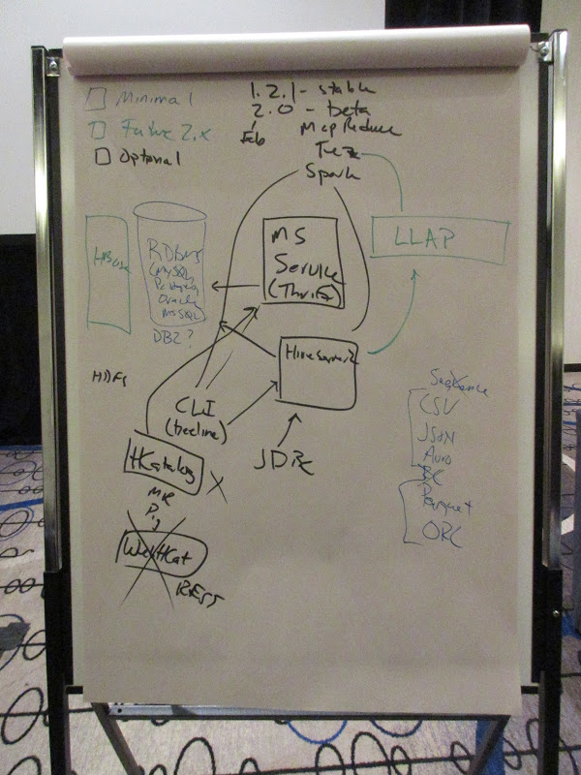

The recommendation for the October ODPi spec was:

* Focus on Hive 1.2 and the metadata returned through JDBC / CLI SQL
* Be neutral with respect to formats - while noting that ORC & Parquet are high priority for participants who were in the room

There was an action for all interested participants to find out from their teams if the metadata returned via JDBC / CLI SQL is sufficient for their needs.

**Discuss issues with the current tests and reference build and how to address them.**

Mr. Gates indicated that there were numerous issues with the current build and CI system. Mr. Day indicated that he is taking over this infrastructure, and will work with Mr. Gates

to fix any issues with tests and reference builds. Mr. Day to explore the introduction of speculative tests as well.

Mr. Mertic indicated that bringing back the sandbox is being investigated by the RT.

**Next Meeting**

The next meeting of TSC is scheduled for Thursday, June 3rd, 2016 at 4:00pm US Eastern Time.

**Adjournment**

There being no further business to come before the meeting, the meeting was adjourned at 12:41 pm Pacific Time.